Learning Task C11
Mark 4:35- 5:43
INTRODUCTION
Introduction
The gospel of Mark focuses heavily on the works of Jesus. Many concluded that it was the first written gospel and was inspired by the teachings of Peter.
Author
John Mark is the author of this gospel.
Date of writing
The date of writing was approximately AD 57- 59.
Historical Setting
The Jews and Christians in Rome were not getting along well with each other, resulting in much hostility and unrest. The first generation of believers was dying out, and as a result, their teachings and testimonies were disappearing as they relied on verbal transmission.

Place of Writing
The Gospel of Mark was written in Rome.
Recipients
The main recipients were the non-Jewish believers in Rome.
Occasion and Purpose
Mark’s purpose was to encourage and guide the believers in living out their faith despite persecution. They were familiar with the gospel but needed help in understanding it; therefore, Mark provided a different perspective.
Theme
The total authority and power of Jesus Christ is revealed to believers, reminding them not to give in to fear but to have faith in Him.

BOOK CHART

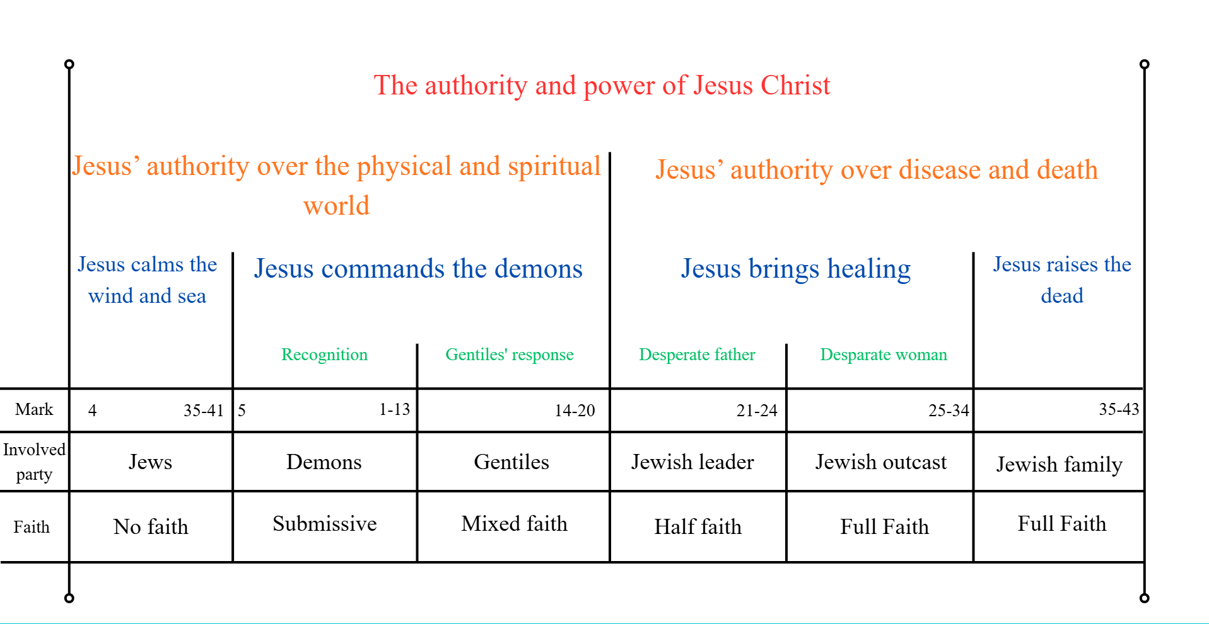
SIMPLE OUTLINE

The authority and power of Jesus Christ (Mark 4:35-5:43)
- Jesus’ authority over the physical and spiritual world (4:35-5:20)

- Jesus calms the sea and wind. (4:35-41)
- Jesus commands the demons. (5:1-20)
  - Recognition. (5:1-13)
  - Gentiles’ response. (5:14-20)

- Jesus’ authority over disease and death. (5:21-43)

- Jesus brings healing. (5:21-34)
  - Desperate father. (5:21-24)
  - Desperate woman. (5:25-34)
- Jesus raises the dead. (5:35-43)

SENTENCE OUTLINE

The total authority and power of Jesus Christ is revealed to believers, reminding them not to give in to fear but to have faith in Him.
I. Jesus displayed His total power and authority over the forces in the physical and spiritual world. (4:35- 5:20)

- Jesus displayed His total power and authority over the physical world when the raging sea and wind obeyed His commands to be calm. (4:35-41)
- Jesus displayed His total power and authority over the spiritual world when all two thousand demons obeyed His command to leave the man and sought permission from Jesus to enter the pigs. (5:1-20)
- The demons recognise the total power and authority of Jesus over them. (5:1-13)
- The Gentiles feared Jesus and wanted Him to leave, but the demon-possessed man wanted to follow Jesus. (5:14-20)
II. Jesus displayed His total power and authority over disease and death. (5:21-43)

- Jesus displayed His total power and authority over disease when a desperate father and woman sought Him for healing. (5:21-34)
- Jairus, a desperate father, seeks Jesus to save his daughter even though Jairus was a synagogue official. (5:21-24)
- A woman who was ill for twelve years was cured by Jesus because of her faith in Him. (5:25-34)
- Jesus displayed His total power and authority over death when Jesus raised Jairus’ daughter from the dead, and she was able to function normally and healthily. (5:35-43)

ARGUMENT

The total authority and power of Jesus Christ is revealed to believers, reminding them not to give in to fear but to have faith in Him.
I. Jesus displayed His total power and authority over the forces in the physical and spiritual world. (4:35- 5:20)

In these verses, Jesus displayed His total power and authority over creation, both physical and spiritual. These displays show that Jesus is God, the creator of the universe.

- Jesus displayed His total power and authority over the physical world when the raging sea and wind obeyed His commands to be calm. (4:35-41)

The same day Jesus began teaching in parables, He led His disciples across the Sea of Galilee (4:35-36). Here, Jesus displayed His total authority and power over the physical world by commanding nature (4:39). However, His disciples not only failed to recognise who Jesus was but also responded in fear to the storm and to Jesus, instead of having faith in Him (4:38, 40- 41).

- Jesus displayed His total power and authority over the spiritual world when all two thousand demons obeyed His command to leave the man and sought permission from Jesus to enter the pigs. (5:1-20)

In these verses, Jesus displays His total power and authority over the demons, reinforcing His identity as God, creator of the universe.

- The demons recognise the total power and authority of Jesus over them. (5:1-13)

By crossing the sea, Jesus and His disciples reached the region of the Gerasenes, where the Gentiles dwell (5:1). They encountered a demon-possessed man, who had multiple demons in him, and no one in the region could subdue him (5:3-5, 9). Here, Jesus’ total authority and power over the spiritual world were displayed when the demons had to obey His commands and seek Jesus’ permission to enter the pigs to destroy them (5:8-14). Even the demons recognised who Jesus was and knew they had to submit to Him (5:7).

- The Gentiles feared Jesus and wanted Him to leave, but the demon-possessed man wanted to follow Jesus. (5:14-20)

This led to two different responses by the people in the region. After witnessing the man freed from his demon possession and hearing the accounts about the pigs, the people begged Jesus to leave their region (5:15-17). However, the man wanted to follow Jesus, but instead was redirected to return home and share what Jesus had done for him (5:18-19). This resulted in many people in Decapolis being amazed by Jesus (5:20).

II. Jesus displayed His total power and authority over disease and death. (5:21-43)

In these verses, Jesus displayed total power and authority over disease and death, two causes of suffering that man could not overcome. This shows that Jesus is not only God the Creator, but He has come to bring salvation to man.

- Jesus displayed His total power and authority over disease when a disease-stricken woman was healed completely because of her faith in Jesus. (5:21-34)
- Jairus, a desperate father, seeks Jesus to save his daughter even though Jairus was a synagogue official. (5:21-24)

After being asked to leave the region of the Gerasenes, Jesus and His disciples crossed back across the sea (5:21). Here, a synagogue official, Jairus, who believed that Jesus could save his daughter from death, came to beg Him for help (5:22-23). Jesus obliged, and a large number of people followed and crowded around Him (5:24).

- A woman who was ill for twelve years was cured by Jesus because of her faith in Him. (5:25-34)

On the way to Jairus’ house, Jesus’ authority and power over any illnesses or diseases were displayed. A woman who was ill for twelve years was instantly healed when she touched Jesus’ cloak, as she believed that He had the power to do so (5:25-29). Jesus commended her faith in Him and confirmed her complete healing from the disease (5:34).

- Jesus displayed His total power and authority over death when Jesus raised Jairus’ daughter from the dead, and she was able to function normally and healthily. (5:35-43)

After healing the woman, news came to Jairus that his daughter had passed away (5:35). Jesus overheard and told Jairus not to give in to fear but to have faith in Him (5:36). Here, Jesus demonstrated His total authority and power over death by raising Jairus’ twelve-year-old daughter from the dead (5:37-42). This astonished all who were present, but Jesus gave strict instructions to not make known to others about this miracle (5:42-43).

BIBILOGRAPHY
Bock, Darrell. “Mark.” In New Cambridge Bible Commentary. Cambridge: Cambridge University Press, 2015. Accessed September 9, 2026. https://www-cambridge-org.dtl.idm.oclc.org/core/books/mark/301290520AF7FF4B35C1A13FE1BCFC7F.

Grassmick, John D. “Mark.” Pages 27n – 2797y in The Bible Knowledge Commentary. Gospels. Edited by John F. Walvoord and Roy B. Zuck. Colorado Springs, CO: David C. Cook, 2018. Accessed September 7, 2026. ProQuest Ebook Central. https://ebookcentral-proquest-com.dtl.idm.oclc.org/lib/dtl/reader.action?docID=5310204&ppg=292&c=UERG

Guzik, David. “Mark 1- The Beginning of the Gospel.” Enduring Word. 1996. Accessed September 9, 2026. https://enduringword.com/bible-commentary/mark-1/.

David Guzik, “Mark 1- The Beginning of the Gospel.” Enduring Word, 1996, accessed September 9, 2026, https://enduringword.com/bible-commentary/mark-1/.
Guzik, “Mark 1- The Beginning of the Gospel.”
John D. Grassmick, “Mark,” in The Bible Knowledge Commentary. Gospels, eds. John F. Walvoord and Roy B. Zuck. (Colorado Springs, CO: David C. Cook, 2018), 27o, accessed September 7, 2026, ProQuest Ebook Central, https://ebookcentral-proquest-com.dtl.idm.oclc.org/lib/dtl/reader.action?docID=5310204&ppg=136&c=UERG.
Grassmick, “Mark,” 27t.
Darrell Brock, “Mark.” In New Cambridge Bible Commentary (Cambridge: Cambridge University Press, 2015), 23, accessed September 9, 2026, https://www-cambridge-org.dtl.idm.oclc.org/core/books/mark/301290520AF7FF4B35C1A13FE1BCFC7F.
Brock, New Cambridge Bible Commentary, 23.
Grassmick, “Mark,” 27t.
Grassmick, “Mark,” 27t.
Grassmick, “Mark,” 27w.
Grassmick, “Mark,” 27w.

